## Reports Menu/Pseudoephedrine/Product Summary:

Request:

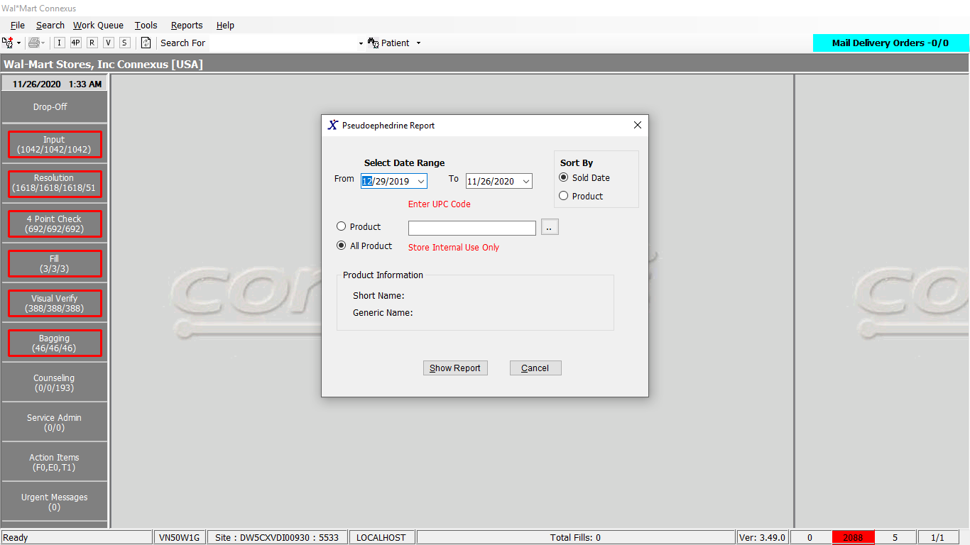

Response:

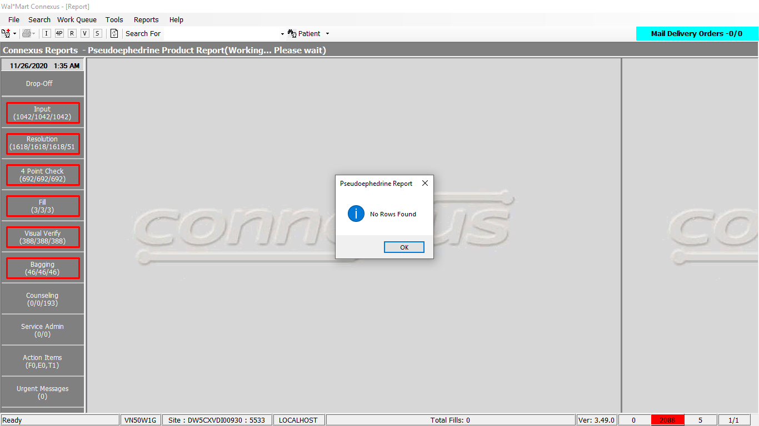

Queries

Public Const GetRestrictedTransactionByProducts As String = "SELECT rt.rstr_txn_id, rt.txn_ts, p.patient_id, rti.mds_fam_id, rti.item_each_qty, rti.item_lot_nbr, " & _

" TRIM(p.last_name) || ', ' || TRIM(p.first_name)patientname, p.birth_date, pp.short_name, pi.upc_nbr," & _

" (pi.inner_pack_qty)packsize, sa.user_descr , sa.UserId " & _

" FROM rstr_txn rt, rstr_txn_item rti, pharmacy_offering:pharmacy_product pp, patient p," & _

" pharmacy_offering:pharmacy_item pi," & _

" phm_appl_security:system_user sa" & _

" WHERE rt.rstr_txn_id = rti.rstr_txn_id" & _

" AND rt.patient_id = p.patient_id" & _

" AND rti.mds_fam_id = pi.mds_fam_id" & _

" AND pi.product_mds_fam_id = pp.product_mds_fam_id" & _

" AND rt.txn_assoc_userid = sa.UserId " & _

" AND sa.store_nbr IS NULL " & _

" AND date(rt.txn_ts) >= ?" & _

" AND date(rt.txn_ts) <= ?"

DAL:

Public Function GetRestrictedTransByProducts(ByVal siteId As Integer, ByVal startDate As DateTime, ByVal endDate As DateTime, Optional ByVal mdsFamId As Integer = 0, Optional ByVal sortOrder As Integer = 0) As List(Of RestrictedTransactionListBE) Implements ITrackerDAL.GetRestrictedTransByProducts

Using (New Tracer(ConnexusCommonConstants.ConnexusTracer))

Dim querySQL As New StringBuilder

'Initialising query

querySQL.Append(TrackerQueries.GetRestrictedTransactionByProducts)

'Adding parameters to param list

Dim paramList As New List(Of DbParameter)

paramList.AddParameter(DbType.String, String.Format(CultureInfo.InvariantCulture, "{0:MM/dd/yy}", startDate))

paramList.AddParameter(DbType.String, String.Format(CultureInfo.InvariantCulture, "{0:MM/dd/yy}", endDate))

If mdsFamId <> 0 Then

querySQL.Append(" AND pi.mds_fam_id = ?")

paramList.AddParameter(DbType.String, mdsFamId)

End If

If sortOrder = 0 Then

'Sort by default SOLD DATE

querySQL.Append(" ORDER BY rt.txn_ts ")

Else

'Sort by default patient name

querySQL.Append(" ORDER BY 9")

End If

Dim listRestrictedTransByProductsBE As New List(Of RestrictedTransactionListBE)

'Execute query

Using dr As IDataReader = ExecuteReader(DatabaseEnum.rx21c, siteId, querySQL.ToString, paramList)

While dr.Read

Dim restrictedTransactionListBE As New RestrictedTransactionListBE

restrictedTransactionListBE.RestrictTransId = dr.GetValueOrDefault(Of Int32)("rstr_txn_id")

restrictedTransactionListBE.TxnTs = dr.GetValueOrDefault(Of DateTime)("txn_ts")

restrictedTransactionListBE.PatientId = dr.GetValueOrDefault(Of Int32)("patient_id")

restrictedTransactionListBE.MdsFamId = dr.GetValueOrDefault(Of Int32)("mds_fam_id")

restrictedTransactionListBE.ItemEachQty = dr.GetValueOrDefault(Of Int16)("item_each_qty")

restrictedTransactionListBE.ItemLotNbr = dr.GetValueOrDefault(Of String)("item_lot_nbr").SafeTrim()

restrictedTransactionListBE.PatientName = dr.GetValueOrDefault(Of String)("patientname").SafeTrim()

restrictedTransactionListBE.BirthOfDate = dr.GetValueOrDefault(Of DateTime)("birth_date")

restrictedTransactionListBE.ShortName = dr.GetValueOrDefault(Of String)("short_name").SafeTrim()

restrictedTransactionListBE.UpcNbr = dr.GetValueOrDefault(Of Decimal)("upc_nbr")

restrictedTransactionListBE.PackSize = dr.GetValueOrDefault(Of Decimal)("packsize")

restrictedTransactionListBE.UserDescription = dr.GetValueOrDefault(Of String)("user_descr").SafeTrim()

restrictedTransactionListBE.UserId = dr.GetValueOrDefault(Of String)("UserId").SafeTrim()

listRestrictedTransByProductsBE.Add(restrictedTransactionListBE)

End While

End Using

If listRestrictedTransByProductsBE.Count = 0 Then

listRestrictedTransByProductsBE = Nothing

End If

Return listRestrictedTransByProductsBE

End Using

End Function